Charity Golf Tournament
To benefit:
Camp Care Therapeutic Riding Program
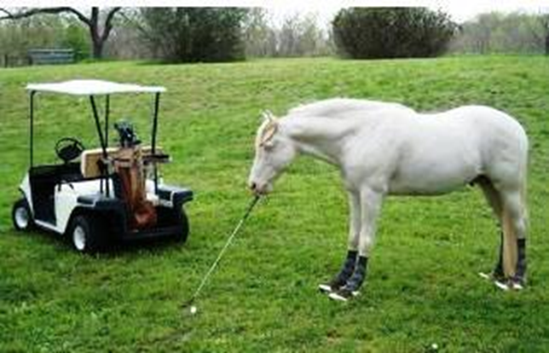

Registration to Golf
Windham Club 184 Club Rd North Windham, CT
JULY 22, 2017
Registration includes gourmet lunch, snacks, 18 holes of golf & shared cart, live music, dinner, silent auction, prizes, putting contest, opportunity to buy mulligans or a shot from “The Pro,” and more!

Registration starts at 12 noon ~ 1 pm Shotgun Start ~ Music on the Deck from 4-6 pm
Silent Auction starts at 5 ~ Dinner at 6 pm
Mail your check(s) made out to Camp Care at 106 Route 66 East, Columbia, CT. 06237.
THANK YOU FOR YOUR SUPPORT OF THIS GREAT LOCAL PROGRAM!
------------------------------------------------------- cut here -----------------------------------------------------------
Name:___________________________________ Phone: _______________________________
Email: ________________________________________________________________________
Player 2: _________________________________ Email: _______________________________
Player 3: _________________________________ Email: _______________________________
Player 4: _________________________________ Email: _______________________________
Number of golfers: _____________ x $140 = ________________ Ck #/Cash: ______________
If you sign up as a foursome the price is $125 per golfer, $500 for the team.
Foursome team name: ___________________ Ck#/Cash: ________________
Additional dinner guests: __________ x $60 = _______________ Ck#/ cash: ______________

